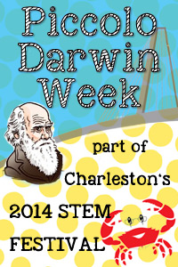
PICCOLO DARWIN WEEK APPLICATION
February, 2014
All programs are free and open to 7th- 12th grade students in Charleston County. But seating is limited and pre-registration required! Applications will be accepted on a first-come, first-served basis.
Please complete the following information and return as an e-mail attachment to Dr. Rob Dillon at dillonr@cofc.edu

Name of school:______________________________________________________________
Address of school:____________________________________________________________

Number and grade level(s) of student applying for program(s) of your choice:
(complete all that apply)
___________The Universe Verse – Tuesday, February 11; 1:30-2:30 pm
___________Animal Attraction – Wednesday, February 12; 1:00-2:00 pm
___________Chemosynthetic Bacteria: Your Most Ancient Relatives? – Thursday,
February 13; 1:30-2:30 pm
How many adults (teachers, parent chaperones) will accompany the students to each program?____________
Name of lead teacher accompanying students:_______________________________________
E-mail address of lead teacher accompanying students:________________________________
Phone number of lead teacher accompanying students:________________________________

Thank you for your interest in Piccolo Darwin Week! We will contact you within 5 school days of the receipt of your application.

